Test Case : 1

Name of Test : Login Check

Name Of Tester : Priyanshu Jha

Input : 1) Entered User Name-FalseID

2) Entered Password- wrong

Output : Login Unsuccessful

Remark : Fine

Input : 1) Entered User Name-admin

2) Entered Password- admin

Output : Login successful

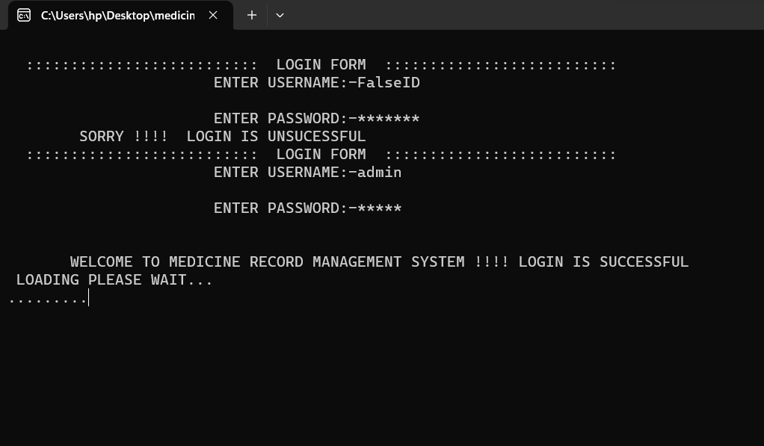

Test Case : 2

Name of Test : Invalid Key Check

Name Of Tester : Priyanshu Jha

Input : 1) Entered wrong Choice Option:

Output : Login Unsuccessful

Remark : Fine

Input : 1) Entered User Name-admin

2) Entered Password- admin

Output : printed message to enter right option

Remark: Fine

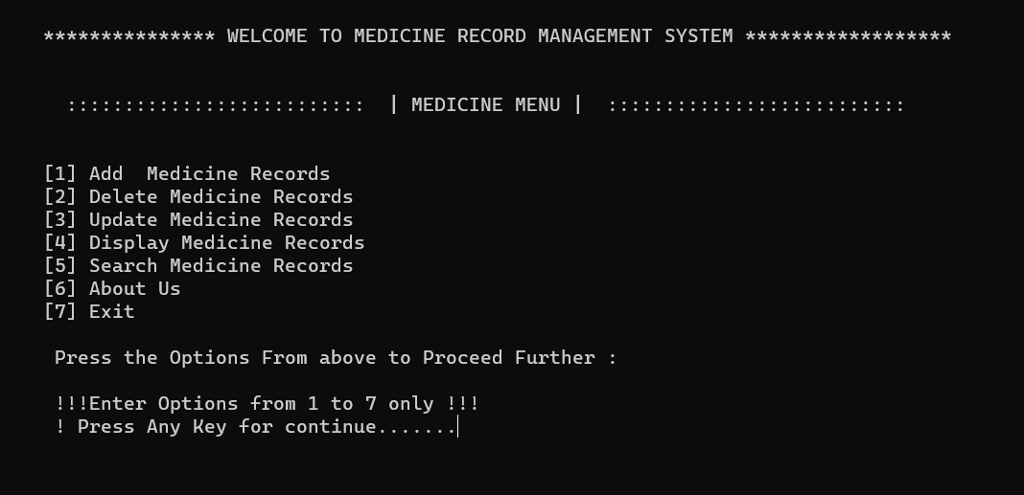

Test Case : 3

Name of Test : About Function Check

Name Of Tester : Priyanshu Jha

Input : 1) Entered 6 as input to choose about

Output : Details regarding the project is shown

Remark : Fine

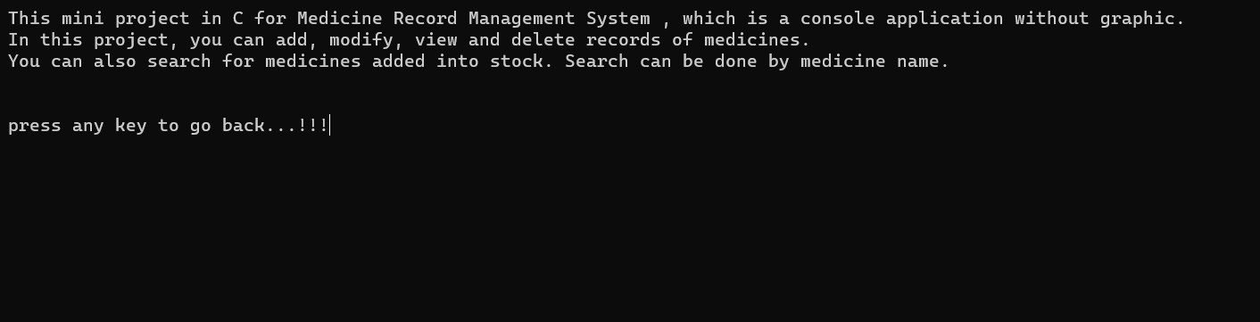

Test Case : 4

Name of Test : Insertion of Record

Name Of Tester : Priyanshu Jha

Input : 1) Entered 1 as input to choose Add Function

2) Entered “Paracetamol” as input for Medicine Name

3) Entered “Normal” as input for Medicine Type

3) Entered “30” as input for Rate

4) Entered “23” as input for Manufacture

5) Entered “26” as input for Expiry

6) Entered “100” as input for Quantity

Output : A message is Displayed that “The Medicine Record has been Inserted !!!”

Remark : Fine

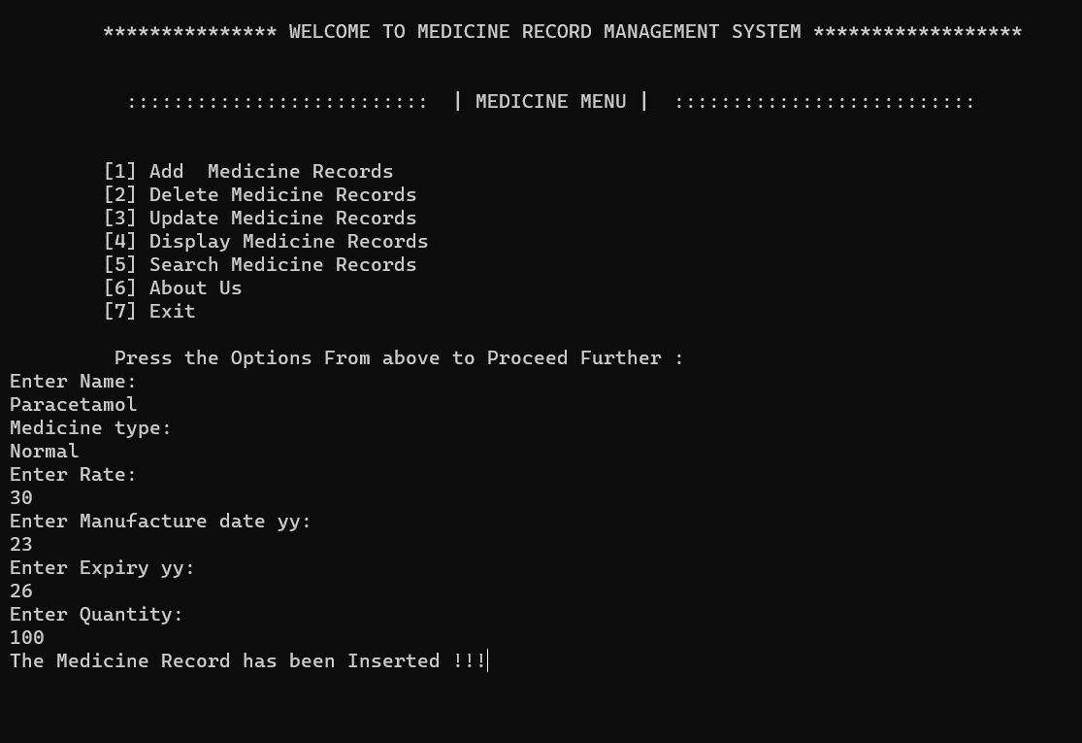

Test Case : 5

Name of Test : Deletion of Record

Name Of Tester : Priyanshu Jha

Input : 1) Entered 2 as input to choose Add Function

2) Entered “VitaminC” as input for Medicine Name

Output : A message is Displayed that “Deleted Successfully !!!” and Record has been deleted from file

Remark : Fine

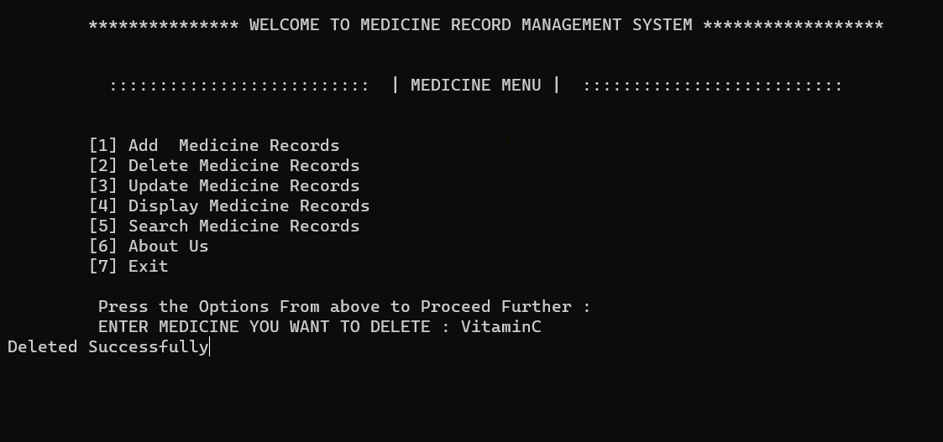

Test Case : 6

Name of Test : Deletion of Record

Name Of Tester : Priyanshu Jha

Input : 1) Entered 2 as input to choose Add Function

2) Entered “VitaminC” as input for Medicine Name

Output : A message is Displayed that “Deleted Successfully !!!” and Record has been deleted from file

Remark : Fine

